**Race Simulation User Guide**

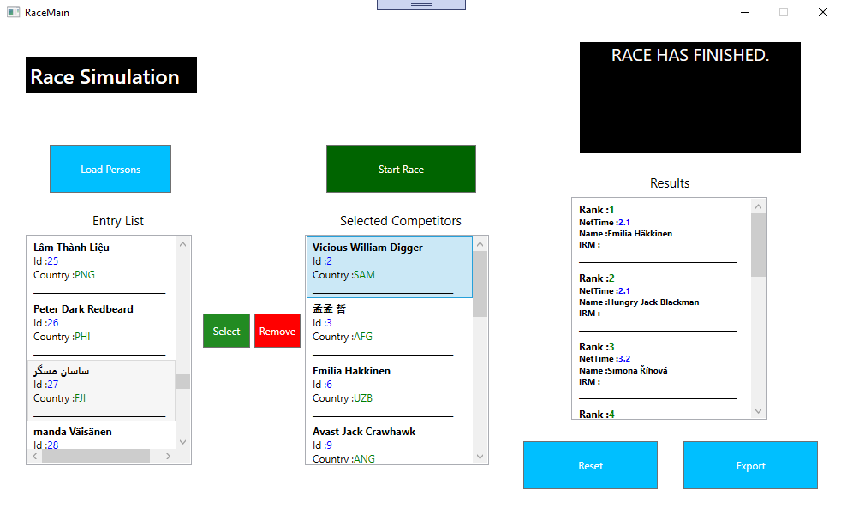

This application is race simulation. Please follow these few steps to use this application.

* Launch Application
* Click **Load Person** Button at the left top in deep sky blue color.
  + It will open a dialog. Please select a valid persons’ xml file.
  + If the xml file is valid the Entry list will be loaded.
* Use can then select each person one by one using **Select** button right next to entry list in green color.
  + Selected user will be added to **Selected Competitor** list (in the middle).
  + To remove any competitor, select it and hit the **Remove** button in red color.
* Hit the **Start Race** button. It is a green button on the top of selected competitor list.
  + It will sort all competitors on the base of their Id.
  + It will then start the race.
* The black box in right top corner will show live updates of the race.
* The **Results list** will show all results with different parameters.
* Hit **Export** button to export entry list and all results in XML file.
* Hit **Reset** button to reset application in its fresh state.